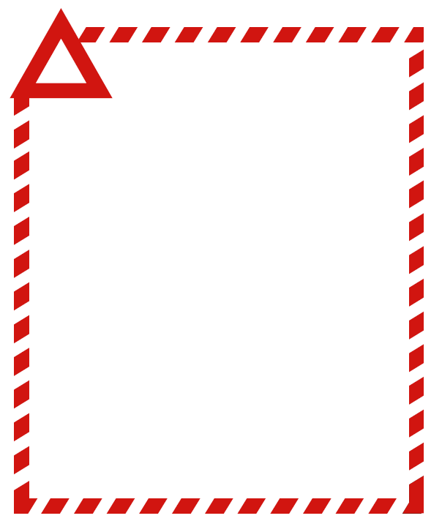

**Product name**

**(insert affected sizes, Use by or Best Before dates)**

{insert product picture}

The recalled product(s) has/have been available for sale in

[insert types of retail outlets] in [insert states, territories or nationally].

**Problem:** The recall is due to (insert the problem, e.g. *Listeria monocytogenes* contamination, the presence of metal fragments, the presence of an undeclared allergen - peanuts).

**Food Safety Hazard:** (if the reason is Listeria the following must be included “*Listeria* *monocytogenes* may cause illness in pregnant women and their unborn babies, the elderly and people with low immune systems”

(If reason is another microbial contamination the following must be included “Food products contaminated with (pathogen) may cause illness if consumed.)

(If the problem is a packaging fault, the presence of foreign matter or chemical contamination the following must be included “Food products containing (matter/chemical) may cause illness/injury if consumed.)

(If the problem is undeclared allergen: the following must be included “Any consumers who have a (insert undeclared allergen) allergy or intolerance may have a reaction if the product is consumed”).

**What to do:** (If reason is any type of microbial contamination the following must be included “Any consumers concerned about their health should seek medical advice”).

(If the problem is a packaging fault or the presence of foreign matter the following must be included “Consumers should not eat this product”)

(If the problem is undeclared allergen: the following must be included

Consumers who have a (insert undeclared allergen) allergy or intolerance should not consume this product”)

Customers should return the product(s) to the place of purchase for a full cash refund (if applicable). We apologise for any inconvenience (optional).

**Contact details:** For further information contact (insert company contact details, including telephone number and web address if available).

**FOOD RECALL**

**See www.foodstandards.gov.au/recalls**

**for Australian food recall information**